**Lecture -3**

# Computer – Operations & Basic Organization

All types of computers follow a same basic logical structure and perform the following five basic operations for converting raw input data into information useful to their users.

|  |  |  |
| --- | --- | --- |
| **Sl.No.** | **Operation** | **Description** |
| 1 | Take Input | The process of entering data and instructions into the computer system |
| 2 | Store Data | Saving data and instructions so that they are available for processing as and when required. |
| 3 | Processing Data | Performing arithmetic, and logical operations on data in order to convert them into useful information. |
| 4 | Output Information | The process of producing useful information or results for the user, such as a printed report or visual display. |
| 5 | Control the workflow | Directs the manner and sequence in which all of the above operations are performed. |

**Basic Organization of Computer System**

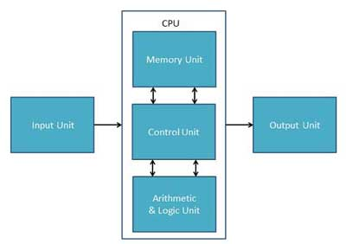

* **Input Unit:** This unit contains devices with the help of which we enter data into computer. This unit makes link between user and computer. The input devices translate the information into the form understandable by computer.
* **CPU (Central Processing Unit):** CPU is considered as the brain of the computer. CPU performs all types of data processing operations. It stores data, intermediate results and instructions(program). It controls the operation of all parts of computer.

CPU itself has following three components

1. ALU(Arithmetic Logic Unit)
2. Memory Unit
3. Control Unit

## Memory or Storage Unit

This unit can store instructions, data and intermediate results. This unit supplies information to the other units of the computer when needed. It is also known as internal storage unit or main memory or primary storage or Random access memory (RAM).

Its size affects speed, power and capability. Primary memory and secondary memory are two types of memories in the computer. Functions of memory unit are:

* It stores all the data and the instructions required for processing.
* It stores intermediate results of processing.
* It stores final results of processing before these results are released to an output device.
* All inputs and outputs are transmitted through main memory.

## Control Unit

## This unit controls the operations of all parts of computer but does not carry out an actual data processing operations. Functions of this unit are:

* It is responsible for controlling the transfer of data and instructions among other units of a computer.
* It manages and coordinates all the units of the computer.
* It obtains the instructions from the memory, interprets them, and directs the operation of the computer.
* It communicates with Input/Output devices for transfer of data or results from storage.
* It does not process or store data.

## ALU(Arithmetic Logic Unit)

This unit consists of two subsections namely

* Arithmetic section
* Logic Section

### *Arithmetic Section*

Function of arithmetic section is to perform arithmetic operations like addition, subtraction, multiplication and division. All complex operations are done by making repetitive use of above operations.

### *Logic Section*

Function of logic section is to perform logic operations such as comparing, selecting, matching and merging of data.

* **Output Unit:** Output unit consists of devices with the help of which we get the information from computer. This unit is a link between computer and users. Output devices translate the computer's output into the form understandable by users.